CURRICULUM VITAE

SURNAME : Fawzy  FIRST NAME : Samiha El Sayed  NATIONALITY : Egyptian  RELIGION : Muslim  DATE OF BIRTH : 13/1/1951  MARITAL STATUS: Married | 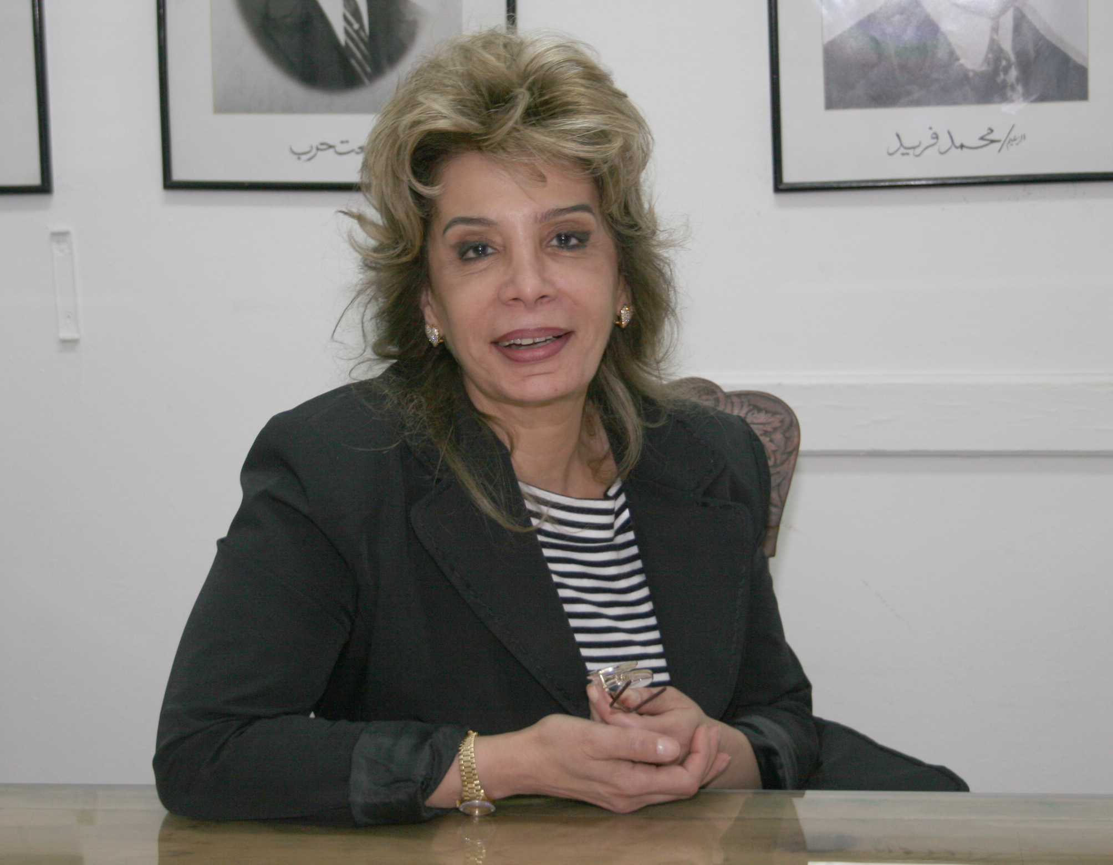

CURRENT POSITION(s):
- Minister of Trade and Industry
- Professor of Economics, Faculty of Economics and Political Science, Cairo University

PREVIOUS WORK EXPERIENCE:
- First Assistant to the Minister of Trade and Industry (2004- 31st January 2011)
- Deputy Director, The Egyptian Center for Economic Studies (1998-2004)

MEMBER AND ADVISOR:
- Board Member, Egypt Export Development Bank (2010-31st January 2011)
- Board Member, The Egyptian Competition Authority (2005-31st January 2011)
- Board Member, The Egyptian Telecommunication Regulatory Authority (2004-31st January 2011)
- Member, The Institute of Directors (2005-2008)
- Board Member, The Capital Market Authority (2004-2006)
- Member Permanent Advisory, General Authority for Investment (2002-2004)
- Advisor, World Bank, Cairo Office (1998-2002)
- Advisor, United Nations Development Program, Cairo Office (1992-2000)
- Advisor, Information Decision Support Center (1994-1998)
- Advisor, United Nations Development Program, Cairo Office (1995-1997)
- Advisor, National Center for Middle East Studies, Cairo Office (1991-1995)
- Advisor, National Center for Social and Criminal Studies (1980-1988)

EDUCATION
- Ph.D. Economics, 1984, Faculty of Economics and Political Science, Cairo University. Thesis title "Analytical Study of the Industrial Sector Structure in Egypt".
- M.Sc. Economics, 1979, Faulty of Economics and Political Science, Cairo University. Thesis title "Industrial Location Theories: Empirical Study of the Location pattern of the Fertilizer Industry in Egypt".
- B.Sc. Economics, 1972, Faculty of Economics and Political Science, Cairo University.

ACADEMIC EXPERIENCE:
- 1972-Present, Professor, Faculty of Economics and Political Science, Cairo University
- 1980-1984, Professor, Faculty of Law, Cairo University
- 1984-1988, Professor, Faculty of Commerce, Cairo University

COURSES TAUGHT:
- Principles of Economics
- Macro and Micro Economics
- Industrial Economics
- Feasibility Studies
- Economics of Multi-National Organizations
- International Trade Theory

PUBLICATIONS AND RESEARCH:
Authored and Co-authored around 40 publications (including research papers, policy view points, working papers, and books) in the following fields;
- International Trade
- Industrial Policy
- Investment Theories
- Multinational Corporations
- Corporate Governance

SUPERVISED THESIS:
Under the following fields
- Corporate Governance
- Rules of Origin
- Currency Crisis and Exchange Rate Policy
- Tourism Industry
- Foreign Direct Investment and Investment Theories
- International Trade
- Industrial Policy
- Economic Development

MERITS AND AWARDS:
- Chevalier Dans L’Ordre National de Merite, awarded by President Nicalos Sarkozy (2010)

